NAME:MEGHANA GANESH
REG NO:210905160
CSE A

LAB EXERCISES
Configure two VMs that will be used to test connectivity from end to end and R1 will
serve as a DHCP server to distribute IP addresses. The diagram below details the
current setup:

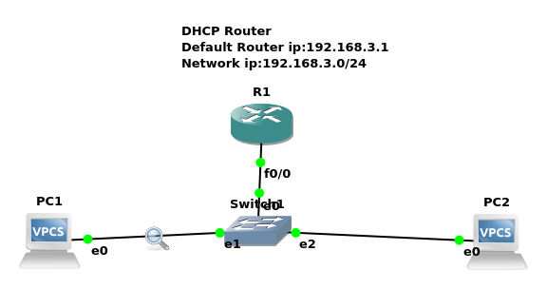
1. In order to configure our router as a DHCP server the following commands were used.
R1(config)#IP dhcp pool NAME
R1(dhcp-config)#Network 192.168.3.0 255.255.255.0
R1(dhcp-config)#Default-router 192.168.3.1
The commands above create a DHCP pool, adds the network that we want to assign IP addresses
from, and specifies the default gateway for this subnet.
Note: There are many other parameters that go into configuring a DHCP server but this will
suffice for our test environment.
That should be it for the DHCP configuration.
2.The next thing that you want to do is configure the fastethernet 0/0 interface which will
connect to our switch.
R1(config)#Interface fastEthernet 0/0
R1(config-if)#No shutdown
R1(config-if)#ip address 192.168.3.1 255.255.255.0
The commands above will turn the interface on and assign an IP address.
3. Turn on the VPCS. In PC1 and PC2 type dhcp
PC1>dhcp
PC2>dhcp
4. Let’s analyze some of the traffic patterns using Wireshark.
In Wireshark we see the following information with regards to DHCP:

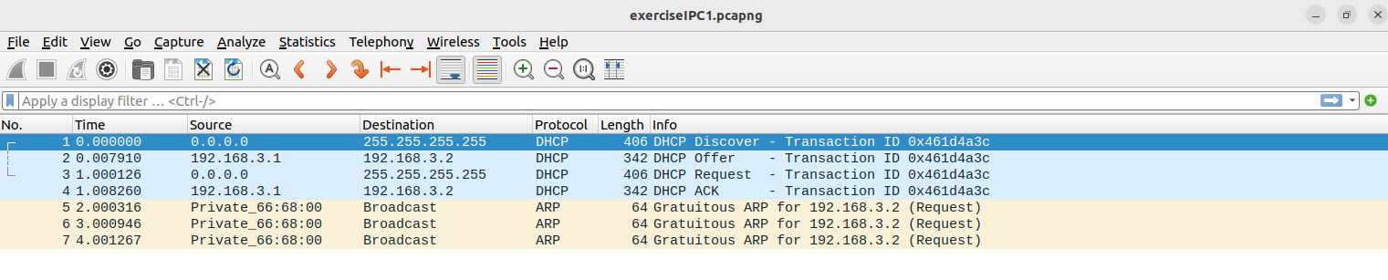
CLASSWORK QUESTION:

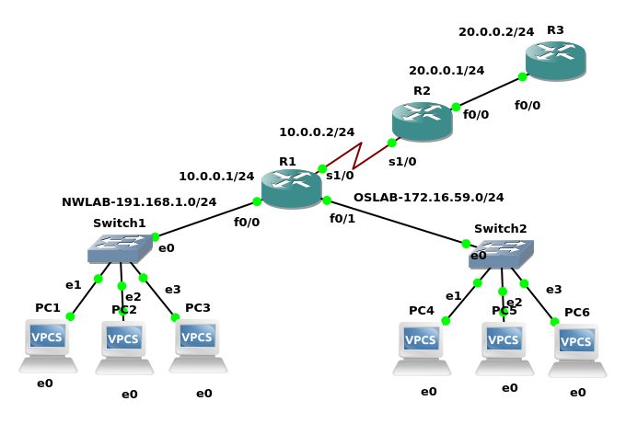
R3:
R3#conf t
R3(config)#ip dhcp pool nwlab
R3(dhcp-config)#network 191.168.1.0 255.255.255.0
R3(dhcp-config)#default-router 191.168.1.254
R3(dhcp-config)#ip dhcp pool oslab
R3(dhcp-config)#network 172.16.59.0 255.255.255.0
R3(dhcp-config)#default-router 172.16.59.254

R3(config)#inter f0/0
R3(config-if)#ip address 20.0.0.2 255.255.255.0
R3(config-if)#no shutdown
R3(config-if)#exit

R3(config)#ip route 191.168.1.0 255.255.255.0 20.0.0.1
R3(config)#ip route 172.16.59.0 255.255.255.0 20.0.0.1
R2:
R2#conf t
R2(config)#inter f0/0
R2(config-if)#ip address 20.0.0.1 255.255.255.0
R2(config-if)#ip helper-address 20.0.0.2
R2(config-if)#no shutdown

R2(config-if)#exit
R2(config)#ip route 20.0.0.0

R2(config)#ip route 20.0.0.0 255.255.255.0 20.0.0.2
R2(config)#ip route 191.168.1.0 255.255.255.0 10.0.0.1
R2(config)#ip route 172.16.59.0 255.255.255.0 10.0.0.1

R1:
R1#conf t
R1(config)#inter s1/0
R1(config-if)#ip address 10.0.0.1 255.255.255.0
R1(config-if)#no shutdown
R1(config-if)#ip helper-address 20.0.0.2
R1(config-if)#exit

R1(config)#inter f0/0
R1(config-if)#ip address 191.168.1.254 255.255.255.0
R1(config-if)#no shutdown
R1(config-if)#ip helper-address 20.0.0.2
R1(config-if)#exit

R1(config)#inter f0/1
R1(config-if)#ip address 172.16.59.254 255.255.255.0
R1(config-if)#no shutdown
R1(config-if)#ip helper-address 20.0.0.2
R1(config-if)#exit

R1(config)#ip route 20.0.0.0 255.255.255.0 10.0.0.2
R1(config)#do wr

